
LESSON NOTE | DETAILED EXPLANATORY NOTES
POPULATION ECOLOGY
SPECIES INTERACTIONS (PREDATION, COMPETITION, SYMBIOSIS)
GRADE 12 - BIOLOGY
■ ■ ■

Living Together in a Community
No species lives alone. In every ecosystem, organisms constantly interact with others - for food, space, mates and survival. A species interaction is any way that two species affect one another. These interactions shape population sizes, drive natural selection, and hold the whole community together. The main types are predation, competition and symbiosis (which includes mutualism, commensalism and parasitism).
This lesson describes each type of interaction, the effect it has on the species involved (using the + / – / 0 system), and real examples - including from Papua New Guinea. It is a core topic in the Population Ecology strand and links closely to population dynamics and energy flow.
Why This Matters
- Interactions control population sizes and keep ecosystems balanced.
- They are a powerful force behind natural selection and adaptation.
- They explain food supply, disease and pest control.
- They guide conservation and biodiversity management.
Species Interactions
Key Learning Outcomes
By the end of this lesson, students should be able to:
- Define a species interaction and use the + / – / 0 effect system.
- Describe predation and predator–prey relationships.
- Explain competition (within and between species) and its outcomes.
- Describe the three types of symbiosis: mutualism, commensalism, parasitism.
- Give examples of each interaction, including in Papua New Guinea.
The Main Types of Interaction
Ecologists describe interactions by their effect on each species: + means the species benefits, - means it is harmed, and 0 means it is unaffected. Using this system, the main interactions can be summarised clearly. Predation helps one (+) and harms the other (–). Competition harms both (– / –). Mutualism benefits both (+ / +). Commensalism helps one and does not affect the other (+ / 0). Parasitism helps one (+) and harms the other (–), like predation but the parasite usually lives on or in its host.
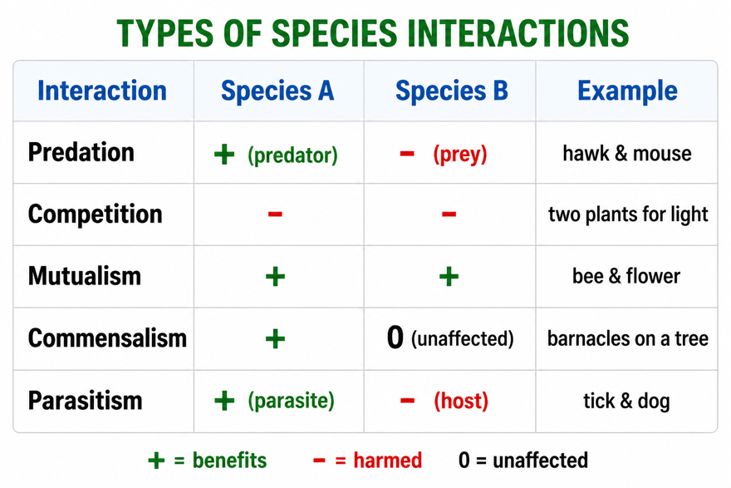
Figure 1: The main types of species interaction and their effects on each species (+ benefits, – harmed, 0 unaffected).
Terminologies and Concepts
Useful terms for this topic:
- Species interaction: any way two species affect one another.
- Predation: one organism (predator) kills and eats another (prey).
- Competition: two organisms need the same limited resource.
- Symbiosis: a close, long-term relationship between two species.
- Mutualism / commensalism / parasitism: +/+ , +/0 , +/– relationships.
- Host: the organism a parasite lives on or in.
- Niche: the role and resources a species uses in its habitat.
Predation
In predation, one organism - the predator - kills and eats another - the prey. Predators are adapted for hunting (sharp claws, speed, good eyesight), while prey have defences (camouflage, speed, warning colours, poisons). Predation keeps prey numbers in check and removes weak or sick individuals. Predator and prey numbers are linked in cycles: when prey are plentiful, predators increase; the extra predators reduce the prey; then, with less food, predator numbers fall, allowing the prey to recover. These linked rises and falls repeat over time.
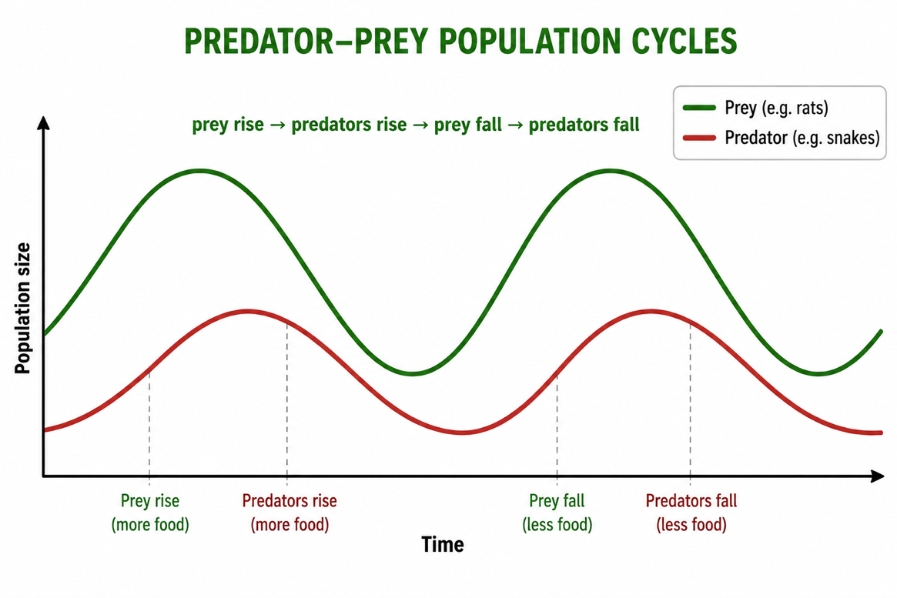
Figure 2: Predator–prey cycles - predator numbers rise and fall a little behind the prey they depend on.
Competition
Competition happens when two organisms need the same limited resource - food, water, light, space or mates - so both are harmed (– / –). There are two kinds. Intraspecific competition is between members of the same species (they need exactly the same things, so it is intense). Interspecific competition is between different species with overlapping needs. Competition can limit population size, and over time it pushes species to use slightly different resources or niches so they can coexist - for example, different birds feeding at different heights in the same tree.
Symbiosis - Living Together
Symbiosis means a close, long-term relationship between two different species. There are three kinds. In mutualism (+ / +), both species benefit - such as a bee getting nectar while pollinating a flower. In commensalism (+ / 0), one benefits and the other is unaffected - such as a bird nesting in a tree. In parasitism (+ / –), one (the parasite) benefits while the other (the host) is harmed - such as a tick feeding on a dog, or worms living in an animal's gut. Parasites usually weaken rather than immediately kill their host.
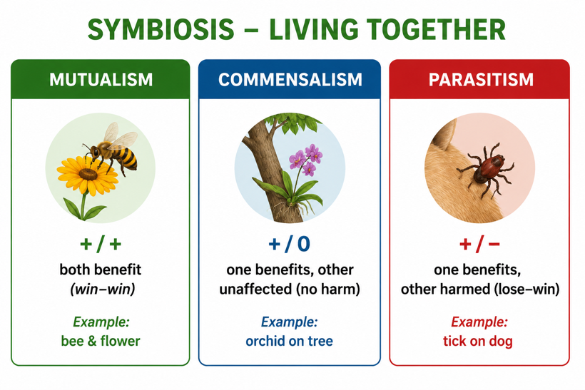
Figure 3: The three types of symbiosis - mutualism (+/+), commensalism (+/0) and parasitism (+/–).
Why This Matters
- Balance - interactions keep population sizes and ecosystems stable.
- Evolution - they drive adaptations in predators, prey, hosts and parasites.
- Agriculture - competition, pests and pollination all affect farming.
- Health - parasitism underlies many human and animal diseases.
PNG Context Example
Papua New Guinea's rich ecosystems are full of species interactions. Mutualism is everywhere - birds of paradise and other birds pollinate and spread seeds for rainforest plants, and cassowaries are vital seed-dispersers. Predation by snakes, birds of prey and fish controls populations of insects and small animals. Competition shapes which crops and plants thrive in gardens. Parasitism is a major health concern: malaria (a parasite spread by mosquitoes), hookworms and other parasites affect many people. Understanding these interactions helps PNG manage agriculture, health and conservation of its unique biodiversity.
References & Related Documents
Source Documents
- PNG Biology Syllabus (SBC), Grades 11 & 12 - Strand: Ecology / Population Ecology; investigate interactions between organisms (predation, competition, symbiosis) in communities.
- STEM Biology Syllabus - Grade 12. Thema: Ecology; Module: Population Ecology — Species Interactions. Department of Education, PNG.
Further Reading & References
- OpenStax Biology - Community Ecology; Predation, Competition and Symbiosis. https://openstax.org/books/biology
- Khan Academy - Community ecology and species interactions. https://www.khanacademy.org/science/biology/ecology

